**Table 1: Breakdown of Victims by Whether Naxalone Given**

|  |  |  |  |
| --- | --- | --- | --- |
|  | No Naxalone | Naxalone Given | p-value |
| n | 2,864 | 5,661 |  |
| Age.Range (%) |  |  | <0.001 |
| 0 - 9 | 6 ( 0.2) | 4 ( 0.1) |  |
| 10 - 14 | 10 ( 0.3) | 2 ( 0.0) |  |
| 15 - 19 | 80 ( 2.8) | 98 ( 1.7) |  |
| 20 - 24 | 348 (12.2) | 724 (12.8) |  |
| 25 - 29 | 606 (21.2) | 1338 (23.6) |  |
| 30 - 39 | 989 (34.5) | 2109 (37.3) |  |
| 40 - 49 | 467 (16.3) | 793 (14.0) |  |
| 50 - 59 | 269 ( 9.4) | 452 ( 8.0) |  |
| 60 - 69 | 76 ( 2.7) | 123 ( 2.2) |  |
| 70 - 79 | 12 ( 0.4) | 17 ( 0.3) |  |
| 80 - * | 1 ( 0.0) | 1 ( 0.0) |  |
| Race (%) |  |  | <0.001 |
| White | 2516 (87.8) | 4730 (83.6) |  |
| American Indian or Alaskan Native | 0 ( 0.0) | 3 ( 0.1) |  |
| Asian or Pacific Islander | 6 ( 0.2) | 20 ( 0.4) |  |
| Black | 243 ( 8.5) | 418 ( 7.4) |  |
| Unknown | 99 ( 3.5) | 490 ( 8.7) |  |
| Ethnicity.Desc (%) |  |  | 0.274 |
| Not Hispanic | 2222 (77.6) | 4310 (76.1) |  |
| Hispanic | 151 ( 5.3) | 299 ( 5.3) |  |
| Mongolian | 4 ( 0.1) | 4 ( 0.1) |  |
| Unknown | 487 (17.0) | 1048 (18.5) |  |
| Gender.Desc (%) |  |  | 0.023 |
| Female | 914 (31.9) | 1740 (30.7) |  |
| Male | 1939 (67.7) | 3914 (69.1) |  |
| Unknown | 11 ( 0.4) | 7 ( 0.1) |  |
| HEROIN (%) | 1995 (69.7) | 4239 (74.9) | <0.001 |
| FENTANYL (%) | 535 (18.7) | 822 (14.5) | <0.001 |
| UNKNOWN DRUG (%) | 282 ( 9.8) | 1025 (18.1) | <0.001 |
| Survive (%) |  |  | <0.001 |
| N | 1038 (36.2) | 367 ( 6.5) |  |
| U | 129 ( 4.5) | 436 ( 7.7) |  |
| Y | 1697 (59.3) | 4858 (85.8) |  |

**Table 2: Breakdown of Victims by Heroin vs Fentanyl – note that patients with Fentanyl Only are less likely to get Naxalone**

|  |  |  |  |  |  |
| --- | --- | --- | --- | --- | --- |
|  | Neither | Heroin only | Fentanyl Only | Both | p-value |
| N | 2,101 | 5,067 | 190 | 1,167 |  |
| Age.Range (%) |  |  |  |  | <0.001 |
| 0 - 9 | 4 ( 0.2) | 4 ( 0.1) | 0 ( 0.0) | 2 ( 0.2) |  |
| 10 - 14 | 12 ( 0.6) | 0 ( 0.0) | 0 ( 0.0) | 0 ( 0.0) |  |
| 15 - 19 | 96 ( 4.6) | 69 ( 1.4) | 3 ( 1.6) | 10 ( 0.9) |  |
| 20 - 24 | 251 (11.9) | 644 (12.7) | 24 (12.6) | 153 (13.1) |  |
| 25 - 29 | 384 (18.3) | 1239 (24.5) | 36 (18.9) | 285 (24.4) |  |
| 30 - 39 | 680 (32.4) | 1928 (38.1) | 63 (33.2) | 427 (36.6) |  |
| 40 - 49 | 347 (16.5) | 708 (14.0) | 38 (20.0) | 167 (14.3) |  |
| 50 - 59 | 233 (11.1) | 371 ( 7.3) | 21 (11.1) | 96 ( 8.2) |  |
| 60 - 69 | 81 ( 3.9) | 88 ( 1.7) | 5 ( 2.6) | 25 ( 2.1) |  |
| 70 - 79 | 12 ( 0.6) | 15 ( 0.3) | 0 ( 0.0) | 2 ( 0.2) |  |
| 80 - * | 1 ( 0.0) | 1 ( 0.0) | 0 ( 0.0) | 0 ( 0.0) |  |
| Race (%) |  |  |  |  | <0.001 |
| White | 1354 (64.4) | 4643 (91.6) | 171 (90.0) | 1078 (92.4) |  |
| American Indian or Alaskan Native | 1 ( 0.0) | 1 ( 0.0) | 1 ( 0.5) | 0 ( 0.0) |  |
| Asian or Pacific Islander | 8 ( 0.4) | 12 ( 0.2) | 1 ( 0.5) | 5 ( 0.4) |  |
| Black | 263 (12.5) | 313 ( 6.2) | 11 ( 5.8) | 74 ( 6.3) |  |
| Unknown | 475 (22.6) | 98 ( 1.9) | 6 ( 3.2) | 10 ( 0.9) |  |
| Ethnicity.Desc (%) |  |  |  |  | <0.001 |
| Not Hispanic | 1207 (57.4) | 4113 (81.2) | 160 (84.2) | 1052 (90.1) |  |
| Hispanic | 137 ( 6.5) | 233 ( 4.6) | 11 ( 5.8) | 69 ( 5.9) |  |
| Mongolian | 3 ( 0.1) | 4 ( 0.1) | 0 ( 0.0) | 1 ( 0.1) |  |
| Unknown | 754 (35.9) | 717 (14.2) | 19 (10.0) | 45 ( 3.9) |  |
| Gender.Desc (%) |  |  |  |  | <0.001 |
| Female | 739 (35.2) | 1532 (30.2) | 63 (33.2) | 320 (27.4) |  |
| Male | 1356 (64.5) | 3526 (69.6) | 127 (66.8) | 844 (72.3) |  |
| Unknown | 6 ( 0.3) | 9 ( 0.2) | 0 ( 0.0) | 3 ( 0.3) |  |
| Naxalone Given (%) | 1337 (63.6) | 3502 (69.1) | 85 (44.7) | 737 (63.2) | <0.001 |
| UNKNOWN DRUG | 1205 (57.4) | 77 ( 1.5) | 4 ( 2.1) | 21 ( 1.8) | <0.001 |
| Survive (%) |  |  |  |  | <0.001 |
| N | 247 (11.8) | 710 (14.0) | 84 (44.2) | 364 (31.2) |  |
| U | 266 (12.7) | 248 ( 4.9) | 7 ( 3.7) | 44 ( 3.8) |  |
| Y | 1588 (75.6) | 4109 (81.1) | 99 (52.1) | 759 (65.0) |  |

**Table 3: Breakdown of Victims by Use of Unknown Drug**

|  |  |  |  |
| --- | --- | --- | --- |
|  | No Unknown Drug | Unknown Drug | p-value |
| N | 7218 | 1307 |  |
| Age.Range (%) | |  | 0.001 |
| 0 – 9 | 10 ( 0.1) | 0 ( 0.0) |  |
| 10 – 14 | 11 ( 0.2) | 1 ( 0.1) |  |
| 15 – 19 | 145 ( 2.0) | 33 ( 2.5) |  |
| 20 – 24 | 915 (12.7) | 157 (12.0) |  |
| 25 – 29 | 1690 (23.4) | 254 (19.4) |  |
| 30 - 39 | 2628 (36.4) | 470 (36.0) |  |
| 40 - 49 | 1055 (14.6) | 205 (15.7) |  |
| 50 - 59 | 582 ( 8.1) | 139 (10.6) |  |
| 60 - 69 | 154 ( 2.1) | 45 ( 3.4) |  |
| 70 - 79 | 26 ( 0.4) | 3 ( 0.2) |  |
| 80 - * | 2 ( 0.0) | 0 ( 0.0) |  |
| Race (%) |  |  | <0.001 |
| White | 6526 (90.4) | 720 (55.1) |  |
| American Indian or Alaskan Native | Native 2 ( 0.0) | 1 ( 0.1) |  |
| Asian or Pacific Islander | 24 ( 0.3) | 2 ( 0.2) |  |
| Black | 523 ( 7.2) | 138 (10.6) |  |
| Unknown | 143 ( 2.0) | 446 (34.1) |  |
| Ethnicity.Desc (%) | |  | <0.001 |
| Not Hispanic | 5909 (81.9) | 623 (47.7) |  |
| Hispanic | 372 ( 5.2) | 78 ( 6.0) |  |
| Mongolian | 5 ( 0.1) | 3 ( 0.2) |  |
| Unknown | 932 (12.9) | 603 (46.1) |  |
| Gender.Desc (%) | |  | 0.266 |
| Female | 2237 (31.0) | 417 (31.9) |  |
| Male | 4968 (68.8) | 885 (67.7) |  |
| Unknown | 13 ( 0.2) | 5 ( 0.4) |  |
| HEROIN = 1 (%) | 6136 (85.0) | 98 ( 7.5) | <0.001 |
| FENTANYL = 1 (%) | 1332 (18.5) | 25 ( 1.9) | <0.001 |
| Naxalone Given (%) | 4636 (64.2) | 1025 (78.4) | <0.001 |
| Survive (%) |  |  | <0.001 |
| N | 1251 (17.3) | 154 (11.8) |  |
| U | 348 ( 4.8) | 217 (16.6) |  |
| Y | 5619 (77.8) | 936 (71.6) |  |

**Table 4: Statistical Model for Died**

|  |  |  |  |  |  |
| --- | --- | --- | --- | --- | --- |
| ***Statistical Model Predicting Died*** | **Df** | **AIC** | **Likelihood Ratio** | **P-value** |  |
| **<none>** |  | 5985 |  |  |  |
| **Race2** | 2 | 5992.4 | 11.3946 | 0.003355 | ** |
| **Female** | 1 | 5987 | 3.9549 | 0.0467354 | * |
| **Naloxone.Administered:UNKNOWN** | 1 | 5987.5 | 4.4457 | 0.0349891 | * |
| **Naloxone.Administered:Age2** | 6 | 5999.8 | 26.7518 | 0.0001612 | *** |
| **Naloxone.Administered:HEROIN:FENTANYL** | 1 | 5993.2 | 10.1642 | 0.0014319 | ** |

**Table 5: Statistical Model for Narcan given**

|  |  |  |  |  |  |
| --- | --- | --- | --- | --- | --- |
|  | Df | AIC | LRT | Pr(Chi) |  |
| <none> |  | 9786 |  |  |  |
| UNKNOWN DRUG | 1 | 9881.4 | 97.437 | < 2.2e-16 | *** |
| Ethnicity.Desc | 3 | 9781.7 | 1.709 | 0.63493 |  |
| Age2 | 6 | 9791.6 | 17.641 | 0.00719 | ** |
| Race2 | 2 | 9785.8 | 3.851 | 0.14581 |  |
| Female | 1 | 9784 | 0.002 | 0.96042 |  |
| HEROIN:FENTANYL | 1 | 9789 | 5.053 | 0.02458 | * |

**Table 6: Mortality with Drug/Narcan combinations**

|  |  |  |  |  |  |  |
| --- | --- | --- | --- | --- | --- | --- |
|  | No Narcan | | | Narcan | | |
| *Heroin x Fentanyl* | **# Victims** | **# Died** | **% Died** | **# Victims** | **# Died** | **% Died** | **Odds Ratio** |
| Neither Heroin nor Fentanyl | 764 | 153 | 20.03% | 1337 | 94 | 7.03% | 0.30 (0.23-0.40) |
| Heroin Only | 1565 | 526 | 33.61% | 3502 | 184 | 5.25% | 0.11 (0.09-0.13) |
| Fentanyl Only | 105 | 74 | 70.48% | 85 | 10 | 11.76% | 0.06 (0.03-0.12) |
| Both Heroin and Fentanyl | 430 | 285 | 66.28% | 737 | 79 | 10.72% | 0.06 (0.04-0.08) |
| *Unknown Drug* |  |  |  |  |  |  |  |
| No Unknown Drug | 2582 | 954 | 36.95% | 4636 | 297 | 6.41% | 0.12 (0.10-0.13) |
| Unknown Drug | 282 | 84 | 29.79% | 1025 | 70 | 6.83% | 0.17 (0.12-0.25) |

**Table 7: Narcan admin for different drugs (see also Table 1)**

|  |  |  |  |
| --- | --- | --- | --- |
| *Heroin x Fentanyl* | # Victims | # Narcan | % Narcan |
| Neither Heroin nor Fentanyl | 2101 | 1337 | 63.64% |
| Heroin Only | 5067 | 3502 | 69.11% |
| Fentanyl Only | 190 | 85 | 44.74% |
| Both Heroin and Fentanyl | 1167 | 737 | 63.15% |
| *Unknown Drug* |  |  |  |
| No Unknown Drug | 7218 | 4636 | 64.23% |
| Unknown Drug | 1307 | 1025 | 78.42% |

**Figure 1: Percentage died vs Age Bracket**

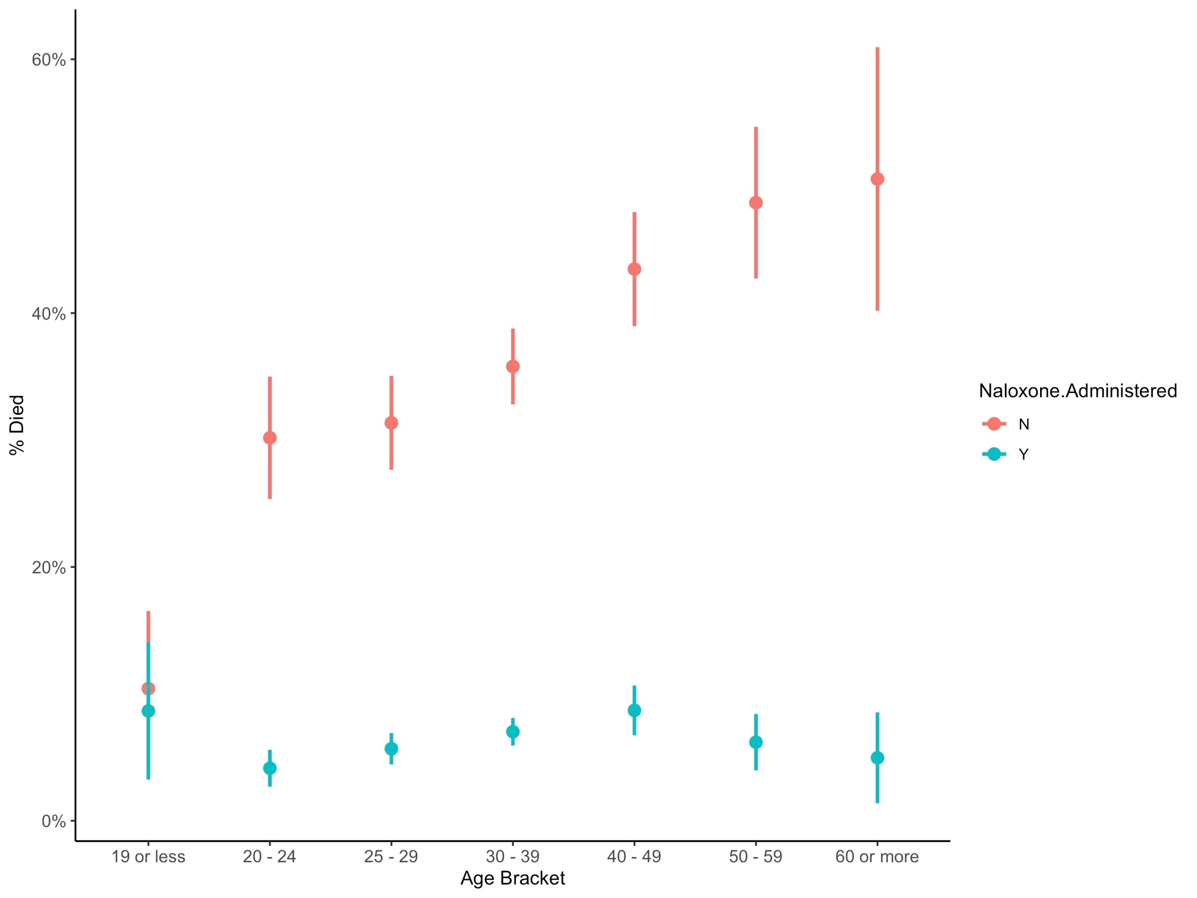

**Figure 2: Distribution of Death Rates across Counties**

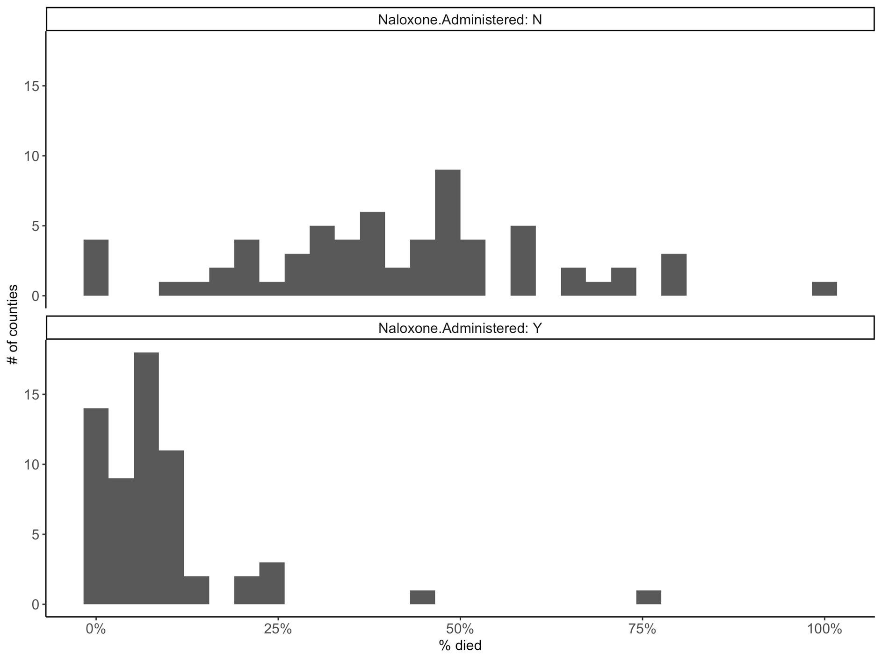

**Figure 3: No relationship between death rates with and without Narcan**

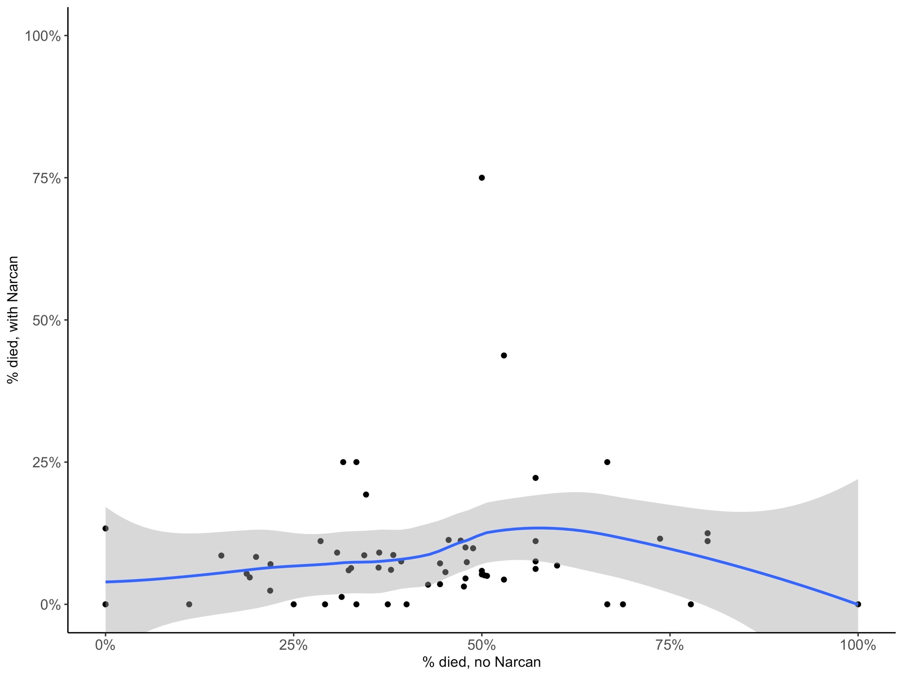

**Figure 4: Distribution of treatment rates across counties**

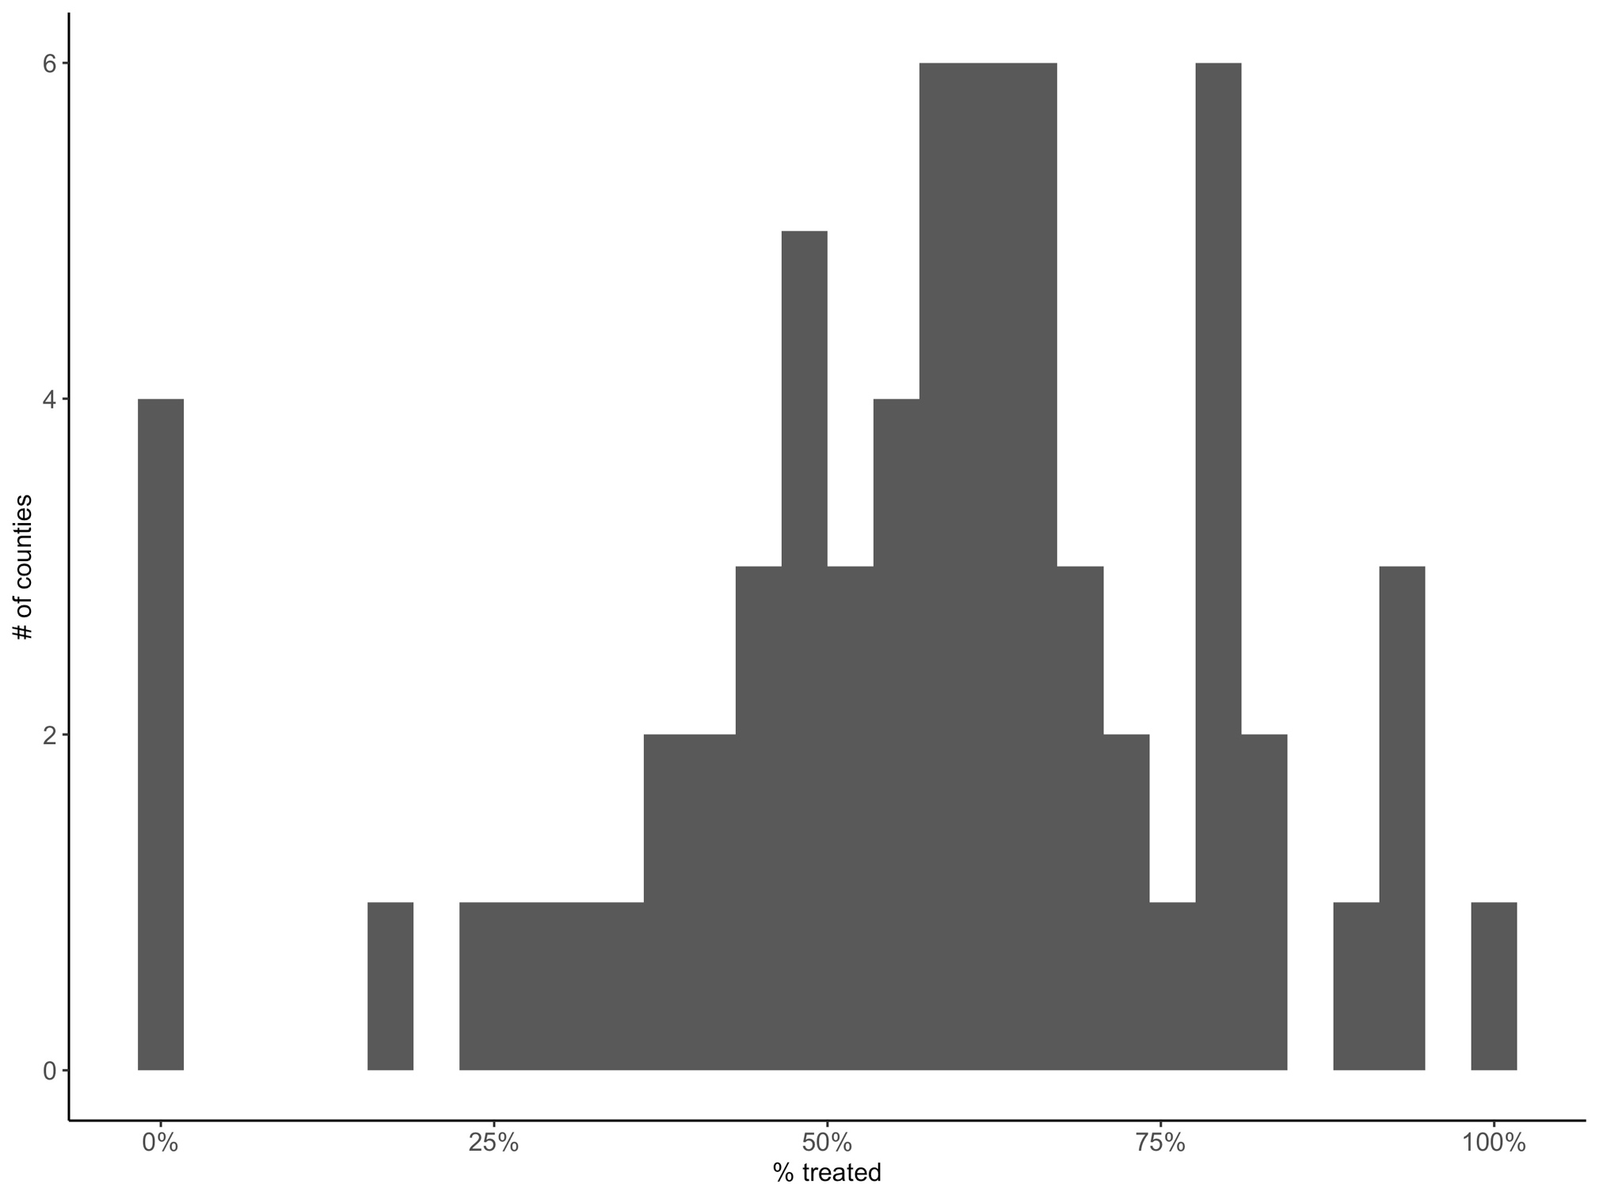

**Figure 5 – the rate of Narcan usages increases with the number of cases in each county**

